EVERGREEN BASIC NEEDS INC.

ANNUAL REPORT

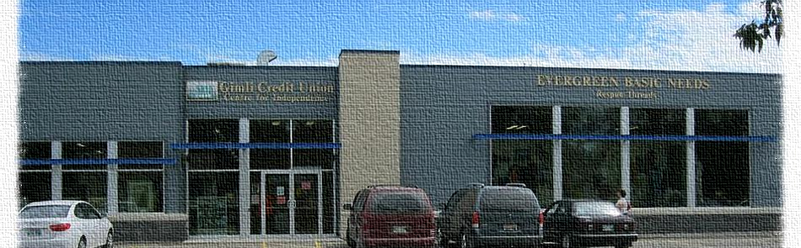

-2014-

The New Year stands before us, like a chapter in a book, waiting to be written. We can help write that story by setting goals. Melody Beattie

Introduction:
Evergreen Basic Needs Inc. (EBN) is an independent non-profit registered charitable organization. EBN is affiliated with, but not through incorporation, Winnipeg Harvest and Manitoba Association of Food Banks. EBN, led by a dedicated volunteer Board of Directors, and has a membership that is made up of EBN volunteers, staff and area residents.
Agency History:
EBN was created in 1992 and incorporated in 1995. The original focus of the organization was to eliminate hunger and food insecurity through food distribution, education and support programs in partnership and cooperation with the community.
In partnership with Winnipeg Harvest, EBN distributes 4000 kg (10,000 pounds) of surplus food on a monthly basis to the Town of Gimli and surrounding communities in Manitoba’s Interlake region.
Since its incorporation, EBN has evolved into a successful social enterprise by operating a store which sells gently used clothing, housewares, furniture and similar used goods. EBN accepts donations from the community and sells them for a profit in the Respun Threads Store. The profits from this venture allow EBN to cover the majority of operating costs and to provide employment for community members.
Mission Statement:
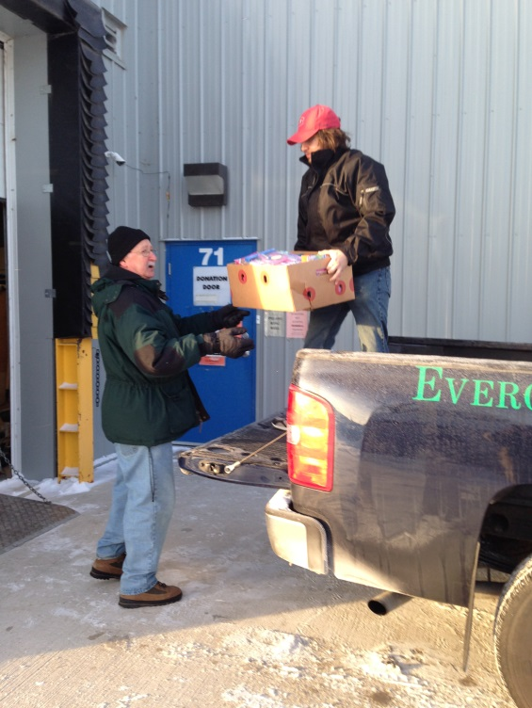
Evergreen Basic Needs is a non-profit organization that provides support to low income individuals and families by offering a wide range of effective programs and services designed to meet the specific and ongoing needs of the community.
Vision Statement
Evergreen Basic Needs is a community inspired center that helps others to help themselves through the strengthening of our collective resourcefulness. This occurs in an environment that is dignified, creative, and warm.

Goals & Objectives
- To assist low-income families with basic needs such as food, clothing, and household items.
- To create programs that provides educational opportunities and training to enhance economic security and prosperity, through effective partnerships with existing resources in the community.
- To serve as a distribution center for other food banks and agencies within the Interlake Region.
- To create and promote programs that assists our clients and their families to have a healthier lifestyle.
Community Service Program
EBN provides two streams of community service programs; the first program is exclusively for High School students enrolled within the Evergreen School Division. Students can earn a credit by volunteering 110 hours. The second program is for individuals who are required to fulfill the obligations of a court mandated community service.
Life Essentials Program
This program offers gently used clothing, furniture and household items to those in need; applicants must fill out a registration form. In 2014, there were 37 requests for merchandise totaling $2,115.00
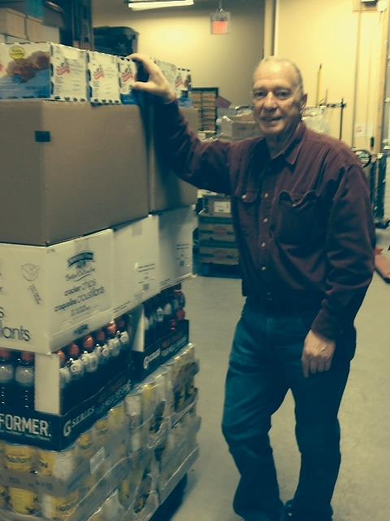
Adult Learning Centre
The Learning Centre provides tutors and support for individuals to obtain a Mature Student High School Diploma. Eleven students were registered with Midland Adult Learning Centre. In addition, in 2014, the following computer classes were offered to EBN clients.
- Introduction to Windows 7
- Introduction to the Internet
- Introduction to MS Word 2010
A grant was provided from the Manitoba Status of Women to host “Power Up” Computer Training Course. Eight participants registered for the program and a waiting list for future computer programs has been established. To address the growing demand for computer training, staff member Miles LaPine, will be providing a fee for service program to assist individual community members.
Helping Hands Café
Our talented and creative kitchen staff prepares scrumptious, home cooked meals and delicious baking for breakfast and lunch at affordable prices. Once a month, the Café becomes the location for a Community Dinner.
Respun Threads
Our gently used clothing, housewares and furniture store provides a constant funding stream for EBN programs and services. All profits generated from store sales stay in the community providing employment, training and support services to Gimli and the surrounding communities in the Interlake region. In 2014, EBN and Respun Threads entered into a partnership with Mother Earth Recycling to sell refurbished computers. The partnership has proven to be highly beneficial to EBN and its customers.
Christmas Hamper Program
In 2014, EBN provided 153 Christmas hampers to families and 125 children each received Christmas gifts and stocking stuffers. None of this would have been possible if not for the generous support of the schools, churches, businesses, and individuals who collected and donated toys, food and money. EBN sent out an appeal when the Christmas toy collection boxes were not attracting the desired attention. Adam T. Elvis responded on the airwaves of CJ107 and sang for toys. The reaction from the public was overwhelming. Hundreds and hundreds of toys and 6,537.50 pounds of food was donated. In addition, EBN exceeded monetary donations from 2013 by a comfortable margin.
Volunteers
EBN is supported by a committed and dedicated volunteer base; in 2014, approximately 11,144.5 hours were donated by 53 individuals. The “team” works closely together and has developed a community within a community. The “B-Side” rings with vibrant personalities; the jewelry divas, the diligent drivers, the Café servers, the smiling store clerks, the sorters, the cleaners, the toys, giftware, housewares ladies and those who wash, knit, sew and craft all are a part of the volunteer team.

The EBN Truck
In the summer of 2014, EBN purchased a truck, with financial assistance from the Westshore Foundation. The truck has proved to be a valuble asset by allowing the food bank to pick up approximately 17,000 pounds of food from Winnipeg Harvest. In addition, EBN collects donations and charges a nominal fee for delivery of furniture purchased from Respun Threads.
EBN Food Bank:
Monetary and food donations help us to supplement the food budget of community members by providing food hampers twice a month to assist families on a short or long term basis.
In March 2014, food banks across Canada conducted a survey of clients on behalf of Food Banks Canada. The people requesting assistance within the EBN catchment area are a diverse group. For example, 29 households are currently employed, and another 9 were recently unemployed. Half are families with children, and nearly half of those households are two-parent families. More than a third of individuals assisted are children –
These households were broken down into categories as follows:
Single-parent: 18
Two-parent: 19
Couples – no children: 8
Single individuals: 42
The primary source of income for households was:
Full and/or part time employment: 29
Employment Insurance: 9
Provincial Social Assistance: 28
Disability related benefits: 4
Old Age Pension: 13
No income: 3
Other income: 1

Month | Hampers 2014 | Hampers 2013 | Adults  2014 | Adults  2013 | Children 2014 | Children  2013
January | 132 | 144 | 205 | 220 | 109 | 133
February | 118 | 138 | 181 | 204 | 98 | 112
March | 118 | 130 | 188 | 193 | 104 | 92
April | 116 | 128 | 196 | 190 | 94 | 97
May | 138 | 124 | 216 | 186 | 102 | 106
June | 118 | 109 | 184 | 169 | 96 | 81
July | 127 | 97 | 188 | 157 | 99 | 73
August | 111 | 105 | 159 | 166 | 85 | 85
September | 114 | 106 | 169 | 174 | 90 | 85
October | 144 | 128 | 204 | 197 | 104 | 112
November | 126 | 117 | 176 | 179 | 94 | 109
December | 153 | 128 | 223 | 198 | 125 | 127
Year totals | 1515 | 1454 | 2289 | 2233 | 1200 | 1212

EBN is rapidly reaching maximum capacity for the individualized food bank program we currently offer EBN clients. Our program is structured to enhance privacy, thereby respecting the dignity of the people utilizing our services. Each individual is allotted 10 - 15 minutes to pick up a hamper and to select items from a special needs section. These Items may include personal care products, clothing, housewares, infant care products, shoes and toys. In 2014, EBN saw a rise in food bank usage.
Community Dinners
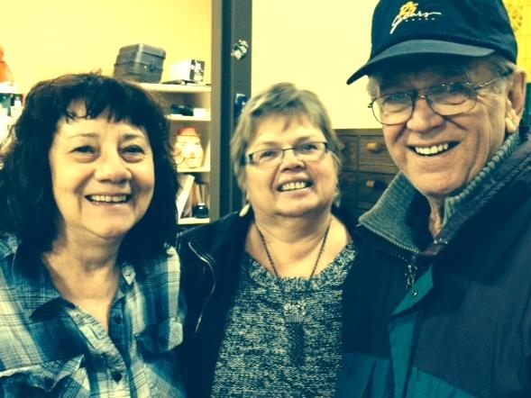
The Community Dinner Program began in 2012 as a monthly addition to the services we currently provide for clients in our catchment area. The Community Dinners are held in the Helping Hands Café and prepared by EBN staff. The Community Dinner concept was originally designed to allow families and individuals who are struggling financially to have an evening out with their family. The Community Dinners cannot be defined as a soup kitchen, nor can it be defined as a food giveaway. It is a community dinner - a hot meal personally served at the table by EBN staff members to every person and family that accepts the invitation. It is an opportunity for camaraderie and friendly conversation. It is an evening of enjoyment, dignity and respect. Due to the fact these meals take place at a location that is familiar and comfortable for the clients, and because many of the clients are repeat attendees, Community Dinners offer a sense of belonging and connection that is vital and hugely appreciated.

Donations
The year in food and material donations (excluding the weekly food pickups at Winnipeg Harvest):
Donations | 2013 | 2014
Bread | 30,515 | 22,049
Food | 13,360.2 | 17,810.8
Distribution Centre | 118,449.7 | 122,529.8
In-coming Donations | 25,438 | 18,444
Out-going Donations | 5,692 | 4,288

Mixed in the donated bags of gently used clothing and boxes of housewares come a number of surpising finds. In 2014, EBN received four authenticated pearl necklaces; one was appraised at $1,800.00 and the other at $987.00. Other “finds” include gold rings, chains, silver pieces, a diamond wedding ring waiting for its owner to claim, a letter dated May 1814, addressed to Mrs. Anderson, cremation urns, cyrstal ware, silver tea sets, Jasper Wedgewood, a first edition signed copy of Billy Graham’s autobiography, “Just as I am.”, countless oddities, such as whales’ teeth and boxes of mournful literary works, once owned by film maker Guy Maddin, designer clothing, mink coats, original artworks, nearly new and antique furniture, a new pair of Ugg boots, books currently on the bestseller’s list, 6 copies of the Titanic on video(at last count), bags of grain and dog coats. The list goes on and on and on. The pearls, the whale’s tooth and Billy Graham’s bio are still for sale.

Report of the Executive Director
During the 2013 AGM, I stated as the new Executive Director of EBN that there would be changes. I kept my word. There were a number of changes - staff changes, some necessary, others unforseen. There were staff members who were here for only a brief period of time, but left a long lasting impression. Others were long term staff members who had no intention of leaving but life made other plans for them.

There have been physical changes in the building, there was program development, creating new partnerships and collaborations. EBN now has a truck to pick up donations and to deliver items purchased in Respun Threads.

There will be changes on the Board of Directors. I would like to take this space to thank Hugh Bond, Lucy Nelson, RubyTretiak, Jim Ingebrigtsen, Jeff Wharton, Larry Moore, Richard Evasiuk, Pam Isfeld, Susan Holfeuer, Peter Holfeuer and Danny Luprypa(ex officio) for their time and contributions. I look forward to working with the new and remaining Directors in the continuing evolution of EBN.

There is no way to fully express my gratitude for the loyalty and commitment of the EBN Team. The team is comprised of both paid and unpaid staff. Their steadfast support during the good times and challenging moments and their encouragement and laughter made the workload lighter and lessened the stress levels. The word “core” can be defined as essential, central, fundamental, heart and foundation; those words describe my “Core” - the EBN staff who keep me sane and keep me focused.
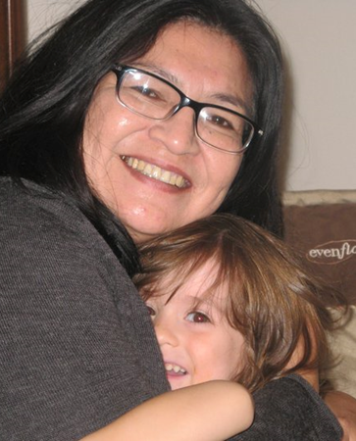
Thank you to our unflappable and judicious EBN Board Chairperson, Larry Moore. Larry’s guidance and advice was indispensable during my formative first year at the helm of EBN.

One area that remained constant and unwavering was the commitment and generousity of the community. I am continually inspired by the dedication and kindness of donors who answer the call to give again and again. To the countless individuals and groups who provide the financial and moral support needed to continue our efforts - Thank You.

Rhonda Powers
Executive Director
Evergreen Basic Needs Inc.

Report of the Chair of the EBN Board of Directors
The past year at EBN has been a bit challenging, as revenue was somewhat lower than expected due largely to the extremely cold winter / spring weather. While store and cafe revenue was much better in the summer and fall, the loss in revenue from January – April did have an impact upon our bottom line at year’s end. Increased hamper requests further added to the challenges of the year.
Despite these challenges, EBN continued to provide bi-weekly and Christmas hampers to those who needed them, continued to host a monthly free meal to designated clients, continued to provide educational opportunities, continued to provide the community with a place to recycle gently used clothing, furniture, housewares and the like, continued to operate a store and cafe that is enjoyed by many and continued to provide employment and volunteer opportunities for over 50 + community members.
Our new Executive Director, Rhonda Powers, has been with us since February 3, 2014. Maintaining the programs and services that work, while still looking for ways to improve what we do, has been her primary focus this past year. While it is true that change can be chaotic, it is also true that change can be cathartic. EBN will continue to change in order to better assist our clients and to serve Gimli and surrounding communities the best that we can.
Thanks to our conscientious EBN staff for all you do to make EBN’s services and programs a reality. Programs do not work unless the right people are there to them work. The right people are an important part of what makes EBN work so well!
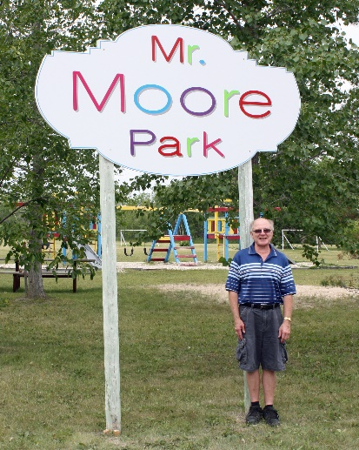
Thanks too to all Board members for the volunteer work they have done on behalf of EBN. EBN is a valued part of Gimli and surrounding communities. The help that EBN provides to those who truly need it is immeasurable and that could not happen without Board members willing to give of their personal time. Thanks for the help and guidance you have unselfishly provided to EBN. Your help and personal commitment has truly made a difference in the lives of many!

Larry Moore
Chair
Evergreen Basic Needs Inc.

Evergreen Basic Needs Staff
Rhonda Powers - Executive Director
Elaine Gibbs – Program Coordinator Gladys Graboweski – Respun Threads Manager
Judy Gilbert/Candace Sable –Interm Office Managers, Rodney Isfeld – Building Manager
Vikki Ranson – Co-Manager Helping Hands Café, Madeline Swaffer-Co-Manager Helping Hands Café
Leslie Samborski – Sales Associate, Marlane Mazur-Sale Associate, Pam Isfeld-Processing
Miles LaPine – B-Side and computer geek, Larry Weber – Custodian/food bank
Rose Achenback, Joan Arnason, Mary Becker, Marie Bond, Marilyn Boychuk, Al Broadhurst, Margaret Chambers, Betty Ducheck,Jim Farmer, Kim Friesen, Marty Friesen, Jillian Friesen, Jocelyn Friesen, Sonya Friesen, Rosa Johnston, Margaret Komar, Dan McKelvey, Dianna McKelvey, Sherolyn Morrisey, Martha Reimer, Betty Richards, Smiling Jack Samborski, Dave Smith, Margaret Thorarinson, Bob Tretiak, Danny-Jo Luprypa, Erika Laqette, Donna Zelenitsky, Margaret Croatto, Marion Tesser, Doris Yanchishyn, Lillian Ward, Sis Thomas Moore, Leif Collins, Judy Gilbert, James O’Neil, Davina and Wayne Griffith, Lloyd Kunz, Marlene Mazur, Shirley Parker-Creasy, Gina Petrowski,Thomas Sauve, Darlene Scaletta, Brenda Whitney, Lisa Chambers, Adam T. Elvis, Braidy Campbell, Zack Stacy, Tiarra and Skye Stacy,
Claire Anne Ayden Hall, Angela Saskosky, Peach (Alexa) Saskosky, Cory Hall and of course, Scott Powers.
A fond farewell to Cindy and Bruce Nicholson, Sheri Scott, Paulla Hill and Darcy Mundey to those who I forgot to name, I apologize for the oversight..

